PRESS RELEASE FOR PUBLICATION

Leonberg, 10 November 2016

Another award:
Brigitte Vöster-Alber receives the “Business Medal of the State of Baden-Württemberg“

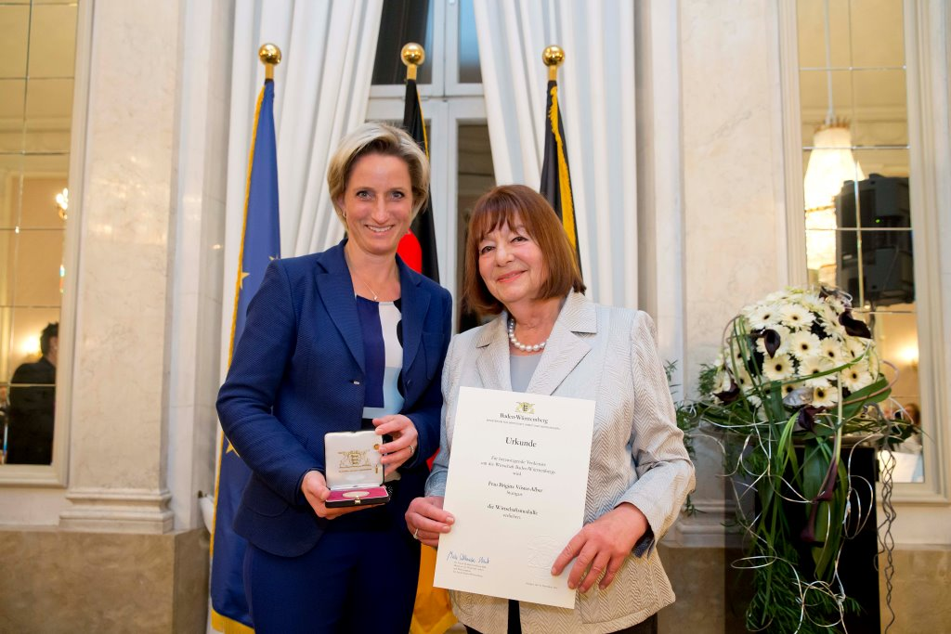

The Minister for Economic Affairs, Labour and Housing in Baden-Württemberg, Dr Nicole Hoffmeister-Kraut, presents the Business Medal of the State of Baden-Württemberg with insignia, certificate, medal and lapel pin in the Marble Hall of the New Palace in Stuttgart. Photo: Ministry of Economic Affairs, Labour and Housing

Brigitte Vöster-Alber, Chief Executive Officer of GEZE GmbH, was handed the Business Medal of the State of Baden-Württemberg by the Minister for Economic Affairs, Dr Nicole Hoffmeister-Kraut. It is awarded to people and companies who have made an outstanding contribution to the economy of Baden-Württemberg. This prestigious award, delivered during a ceremony in Stuttgart’s New Palace, honours Ms Vöster-Alber for decades of entrepreneurial and social merit, and highlights her successful career once again.

“With GEZE you have been successfully leading a globally operating family business for 48 years, which is one of the market and innovation leaders in door, window and safety technology. Your contemporary, future-driven way of thinking is a crucial factor in the company’s success. Likewise, the promotion of women and the balancing of work and family life in your company are crucial. With the creation and maintenance of jobs as well as the diverse training opportunities for young people, you are clearly committed to Baden-Württemberg as a place to do business,” said Minister Hoffmeister-Kraut in her laudation.

In addition to her entrepreneurial achievements, the minister also emphasised Brigitte Vöster-Alber’s long-standing public and social commitment to art, culture and sport, and to the Stuttgart Olgäle-Stiftung für das kranke Kind e.V. (Olgäle Foundation for sick children), among other things. It is therefore not surprising that she has already been honoured with the Order of Merit of the Federal Republic of Germany as well as the Konrad-Adenauer-Stiftung Prize for Social Market Economy, and was named honorary citizen of the city of Leonberg in 2013.

One step ahead of the future
Thinking and acting with a view to the long-term, organic growth and the fundamental principle of long-term, sustainable revenue are priorities for Brigitte Vöster-Alber. The workforce has been increasing for years, amounting to almost 2,800 today. Although operating globally, she and her company are committed to Germany as its primary development and production location. With 31 subsidiaries, 27 of which are abroad, the international operations consolidate the sites in Germany. Since 2010, around 24 million euros have been invested in constructing and expanding buildings, in state-of-the-art technical facilities as well as production and logistics facilities at GEZE’S headquarters in Leonberg. They will ensure the prerequisites for future-driven innovative products that will secure the success of the company and its growth in the coming years, and create further attractive jobs.

Attractive jobs – innovative strength as a corporate principle
GEZE has won the prestigious Top 100 award for the seventh time for its innovation management, and it is one of the most innovative companies in Germany. The company was honoured as Top Employer in Germany and Top Employer of Engineers on several occasions for outstanding personnel management. Brigitte Vöster-Alber is particularly proud of the fact that GEZE is also one of the most sought-after employers among engineers. Employees are supported individually because highly qualified specialists and executives are crucial in a highly specialised technology company. GEZE offers training courses and dual degree programmes in various disciplines. GEZE balances work and family life through individual working time models and working from home.

